**Program screenshots**

1. Insert operation

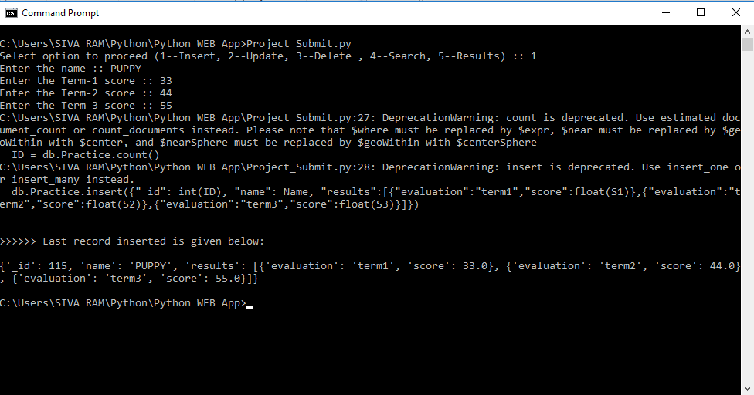

1. Update operation  
     
   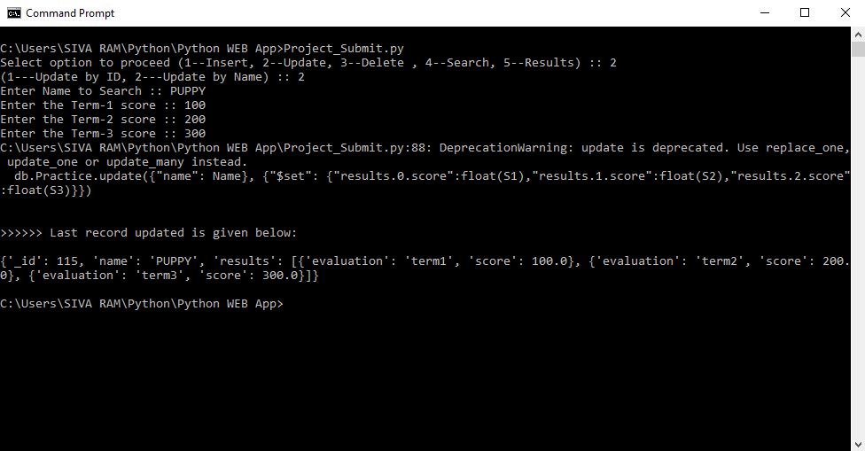
2. Delete Operation  
     
   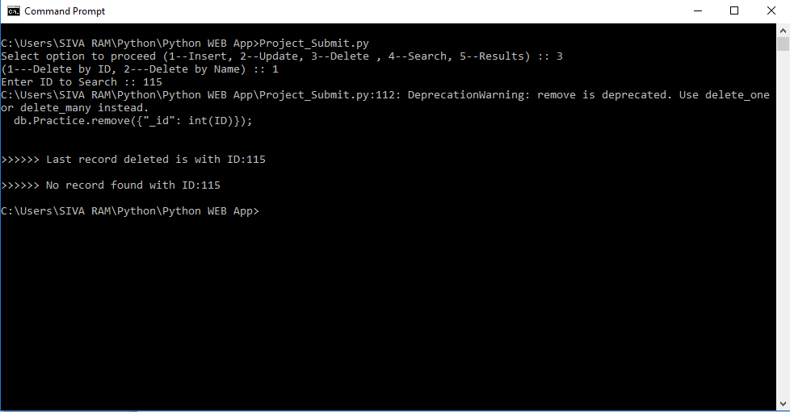
3. Search operation  
     
   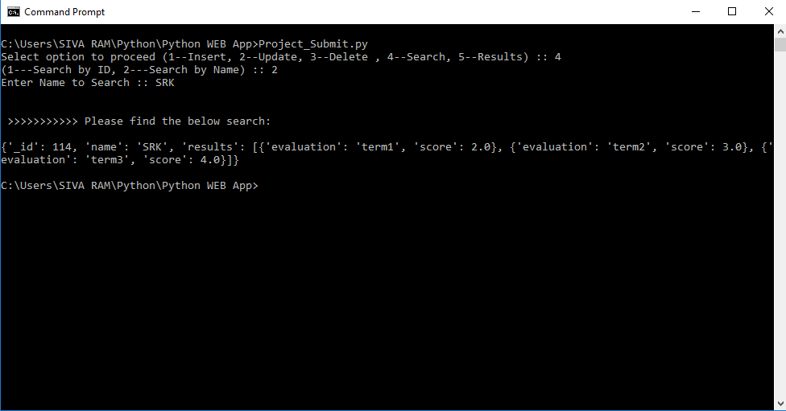
4. Results fetch --- Employee training score analysis  
   1. Find count and percentage of employees who failed in term 1, the passing score being 37

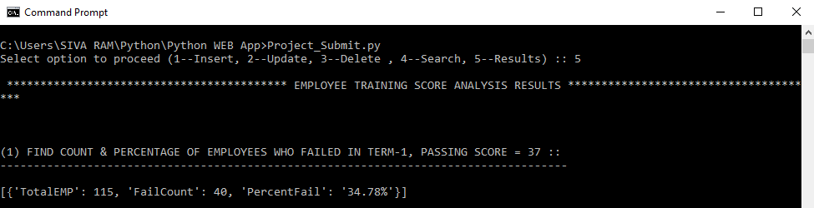

***Solution query:****db.Practice.aggregate([*

*{$unwind: "$results"},*

*{$match: {"results.evaluation":"term1"}},*

*{$group: {*

*_id: null,*

*TotalEMP: {$sum: 1},*

*FailCount: {$sum: {"$cond": [{ "$lt": ["$results.score", 37 ] },1 ,0]}}}},*

*{$project: {*

*_id: 0,*

*TotalEMP:1,*

*FailCount:1,*

*PercentFail: {$concat: [{$toString: {$divide: [{$trunc: {$multiply: [{$multiply: [{$divide:*

*["$FailCount","$TotalEMP"]},100]},100]}},100]}},"","%"]}*

*}}*

*]);*

* 1. Find employees who failed in aggregate (term1 + term2 + term3)

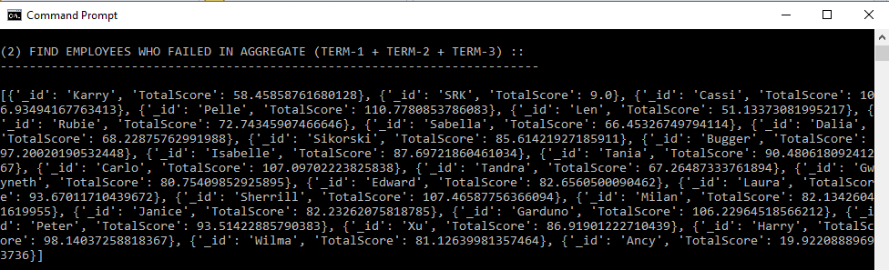 ***Solution query:****db.Practice.aggregate([*

*{$unwind: "$results"},*

*{$group: {*

*_id: "$name",*

*TotalScore: {$sum: "$results.score"}*

*}*

*},*

*{$match: {TotalScore: { $lt: 37*3 } } },*

*{$project: {*

*_id:1,*

*TotalScore:1*

*}*

*}*

*]);*

* 1. Find the Average score of trainees for term1

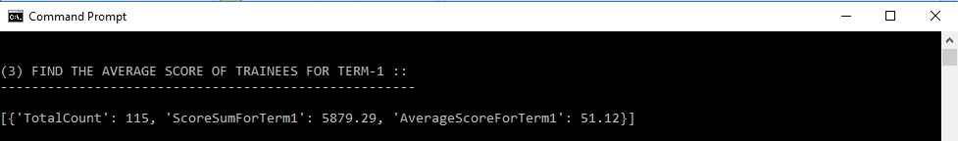

***Solution query:****db.Practice.aggregate([*

*{$unwind: "$results"},*

*{$match: {"results.evaluation": "term1"}},*

*{$group: {*

*_id: null,*

*TotalCount: {$sum: 1},*

*ScoreSumForTerm1: {$sum: "$results.score"}*

*}*

*},*

*{$project: {*

*_id:0,*

*TotalCount: 1,*

*ScoreSumForTerm1: {$divide: [{$trunc: {$multiply: ["$ScoreSumForTerm1",100]}},100]},*

*AverageScoreForTerm1: {$divide: [{$trunc: {$multiply: [{$divide: ["$ScoreSumForTerm1", "$TotalCount"]},100]}},100]}*

*}*

*}*

*]);*

* 1. Find the Average score of trainees for aggregate (term1 + term2 + term3)

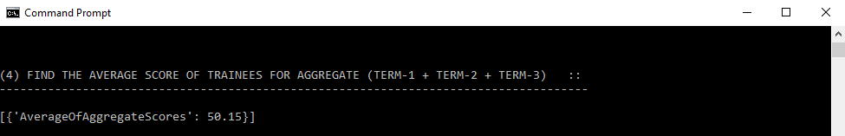

***Solution query:****db.Practice.aggregate([*

*{$unwind: "$results"},*

*{$group: {*

*_id: null,*

*AverageOfAggregateScores: {$avg: "$results.score"}*

*}*

*},*

*{$project: {*

*_id:0,*

*AverageOfAggregateScores: {$divide: [{$trunc: {$multiply: ["$AverageOfAggregateScores",100]}},100]}*

*}*

*}*

*]);*

* 1. Find number of employees who failed in all the three (term1 + term2 + term3)

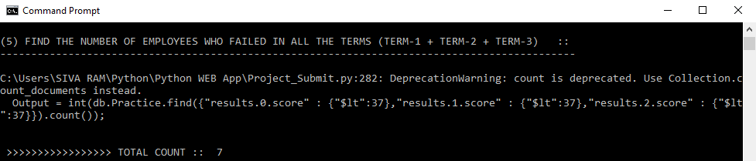

***Solution query:****db.Practice.find({"results.0.score" : {$lt:37},"results.1.score" : {$lt:37},"results.2.score" : {$lt:37}}).count();*

* 1. Find the number of employees who failed in any of the three (term1 + term2 + term3)

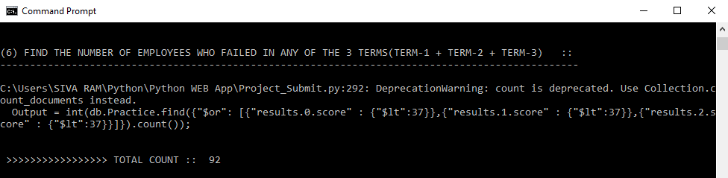

***Solution query:****db.Practice.find({$or: [{"results.0.score" : {$lt:37}},{"results.1.score" : {$lt:37}},{"results.2.score" : {$lt:37}}]}).count();*